##### A PROJECT REPORT

**ON**

**FACE DETECTION BASED ATTENDANCE SYSTEM USING ESP 32**

##### Submitted in partial fulfillment for the award of degree of Bachelor of Technology Rajasthan Technical University, Kota



**2022-23**

#### Guided by Submitted by

Ms. MAMTA RANI VANSHIKA SONI (19EJCEC817)

Assistant Professor TEENA GURJER (19EJCEC809)

Department of ECE VIPUL KHANNA (19EJCEC822) SHASHANK SINGH(19EJCEC188)

**DEPARTMENT OF ELECTRONICS & COMMUNICATION ENGINEERING JAIPUR ENGINEERING COLLEGE & RESEARCH CENTRE, JAIPUR SHRI RAM KI NANGAL, VIA SITAPURA RIICO JAIPUR -302022**

**MAY 2023**

## CERTIFICATE

This is to certify that Project Titled **“**Face Detection Based Attendance System Using ESP 32**”** is the Bonafide work carried out by VANSHIKA SONI (19EJCEC817), TEENA GURJAR (19EJCEC809), VIPUL KHANNA (19EJCEC822), SHASHANK

SINGH (19EJCEC188) the Student of B. Tech (ECE) of Jaipur Engineering College and Research Centre, Jaipur affiliated to Rajasthan Technical University, Kota, Rajasthan, (India} during the academic year 2022-23. in partial fulfillment for the award of degree of Bachelor of Technology (Electronics & Communication Engineering) and that the project has not formed the basis for the award previously of any other degree, diploma, fellowship or any other similar title.

(Signature of Guide)

Ms. MAMTA RANI (Assistant Professor)Department of ECE

## ACKNOWLEDGEMENT

The success and outcome of this Project report required a lot of guidance and assistance from many people, and we are extremely privileged to have got this all along the completion of our course and few of the projects. All that we have doneis only due to such supervision and assistance and we would not forget to thank them. Deepest thanks to our Project Supervisor Ms. Mamta Rani for providing encouragement, constant support and guidance which was of a great help to complete this Project report successfully. We would also like it thank our Head of Department (ECE) Dr. Sandeep Vyas and Project Coordinators Mr. Vikas Sharma and Dr. Girraj Sharma for their constant guidance and suggestions,

Last but not the least, we wish to thank our parents for financing our studies in this college as well as for constantly encouraging us to learn engineering. Their personal sacrifice in providing this opportunity to learn engineering is gratefully acknowledged.

## TABLE OF CONTENTS

* CERTIFICATE I
* ACKNOWLEDGEMENT II
* LIST OF FIGURES V
* LIST OF ABBREIVATIONS VI
* ABSTRACT 1
* REFERENCES…………………………………………………………65
* Chapter-1
  1. System Using ESP 32 3
  2. Types of camera module 4
  3. Problem Solution 4
* Chapter-2
  1. What is Arduino 7
  2. Types of Arduino 7
     1. Arduino Duo 11
     2. Arduino Leonardo 11
     3. Arduino Pro Mini 12
     4. Arduino MKR 13
     5. Arduino UNO 14
     6. Arduino NANO 15
  3. 12
     1. Components Used in Arduino 12
     2. Design of Arduino 13
     3. Attractive features 13
     4. ESP Cam Module 14
* Chapter-3
  1. Introduction 14
  2. Arduino IDE 15
  3. USB Drivers 16
  4. Libraries 16
* Chapter-4

4.1Flowchart of Face Detection Algorithm 17

* 1. Flow chart of Face Recognition Algorithm 18
  2. How to Use Camera Module With Arduino… 19
* CONCLUSION AND FUTURE SCOPE
* RESULT

## LIST OF FIGURES

1. Block Diagram of the System
2. .Schematic Diagram of Hardware Connections 3.Flowchart of Face Detection Algorithm 4.Flowchart of Face Recognition Algorithm
3. Sample Image Captured by the Camera Module
4. Sample Image with Detected Face
5. Sample Image with Recognized Face
6. Screen Shot of Attendance Log 9.Performance Evaluation Graph 10.Bar Chart of Attendance Statistics

## LIST OF ABBREIVATIONS

1. ESP32: Express if System Platform 32
2. CPU: Central Processing Unit
3. ADC: Analog-to-Digital Converter
4. DAC: Digital-to-Analog Converter
5. UART: Universal Asynchronous Receiver-Transmitter
6. SPI: Serial Peripheral Interface
7. I2C: Inter-Integrated Circuit
8. PWM: Pulse Width Modulation
9. TFT: Thin Film Transistor
10. OV7670: Omnivision 7670 Camera Module

## ABSTRACT

*The Face Detection Based Attendance System Using ESP 32 is a project that aims to develop a system that can automatically detect and recognize the faces of individuals to record their attendance in real-time. This system uses a low-cost ESP32 microcontroller with built-in Wi- Fi and Bluetooth capabilities, an OV7670 camera module, and a TFT display to capture images, process them, and display attendance data.*

*The system uses the OpenCV library for face detection and the face recognition library to recognize the faces of individuals.*

*The system eliminates the need for manual attendance tracking and provides a more efficient and accurate method of tracking attendance. This system can be used in schools, colleges, and offices to track attendance and generate attendance reports and statistics. The system can also be improved by using a higher-quality camera module and additional processing techniques to improve face detection.*

# CHAPTER- 1 INTRODUCTION

The Face Detection Based Attendance System Using ESP 32 is a system that aims to simplify attendance tracking by automatically detecting and recognizing the faces of individuals in real - time. The system uses a low-cost ESP32 microcontroller, an OV7670 camera module, and a TFT display to capture images, process them, and display attendance data. The system utilizes the OpenCV library for face detection and the face recognition library to recognize the faces of individuals.

Attendance tracking is a critical process in schools, colleges, and offices as it helps in monitoring attendance and tracking the performance of students or employees. Traditional attendance tracking methods such as manual paper-based attendance tracking are often time- consuming and inefficient. The use of technology in attendance tracking has become increasingly popular, and face recognition technology is one of the most promising methods for automating attendance tracking.

This project aims to develop an attendance tracking system that utilizes face detection and recognition technology to provide an efficient and accurate method of tracking attendance. The system can be easily integrated with other systems and applications through the use of APIs, making it a flexible and versatile solution for attendance tracking.

This project report will discuss the system's hardware and software components, the face detection and recognition algorithms used, the system's performance evaluation, and the future scope of the project. The report will also discuss the advantages and limitations of the system and its potential impact on attendance tracking in schools, colleges, and offices.

Advantages of this system include its compact size, low power consumption, and ease of integration with existing infrastructure. Additionally, it offers the potential for automation, reducing manual data entry and improving accuracy. Keep in mind that implementing this system requires programming skills, understanding of image processing algorithms, and familiarity with microcontroller development. Detailed tutorials and code examples are available online to guide you through the setup process.

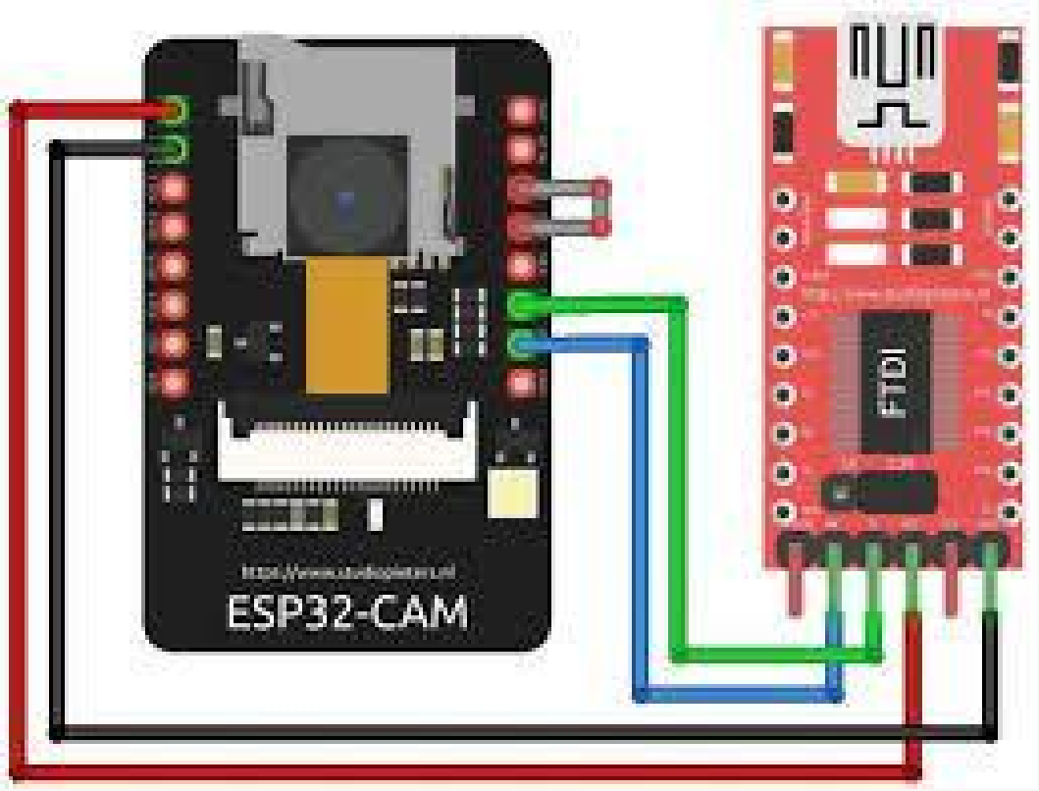

## WHAT IS ESP 32

ESP32 is a low-cost, low-power consumption microcontroller with built-in Wi-Fi and Bluetooth capabilities. It is a powerful microcontroller with an integrated 2.4GHz Wi-Fi and Bluetooth Low Energy (BLE) module that makes it an ideal choice for developing Internet of Things (IoT) applications. The ESP32 microcontroller features two 32-bit Ten silica LX6 CPU cores, up to 240MHz clock frequency, and a large number of peripherals, including capacitive touch sensors, ADCs, DACs, UARTs, SPIs, I2Cs, PWMs, and timers. Additionally, the ESP32 microcontroller is compatible with Arduino and can be programmed using the Arduino IDE or the Express if IoT Development Framework (ESP- IDF). The ESP32 microcontroller is widely used in a variety of applications, including home automation, industrial automation, robotics, and wireless sensor networks.

#### TYPES OF ESP32 CAM

##### AI-Thinker ESP32-CAM:

This is one of the most widely used ESP32-CAM modules and comes with a OV2640 camera module, 4MB flash memory, and a built-in Wi-Fi antenna.

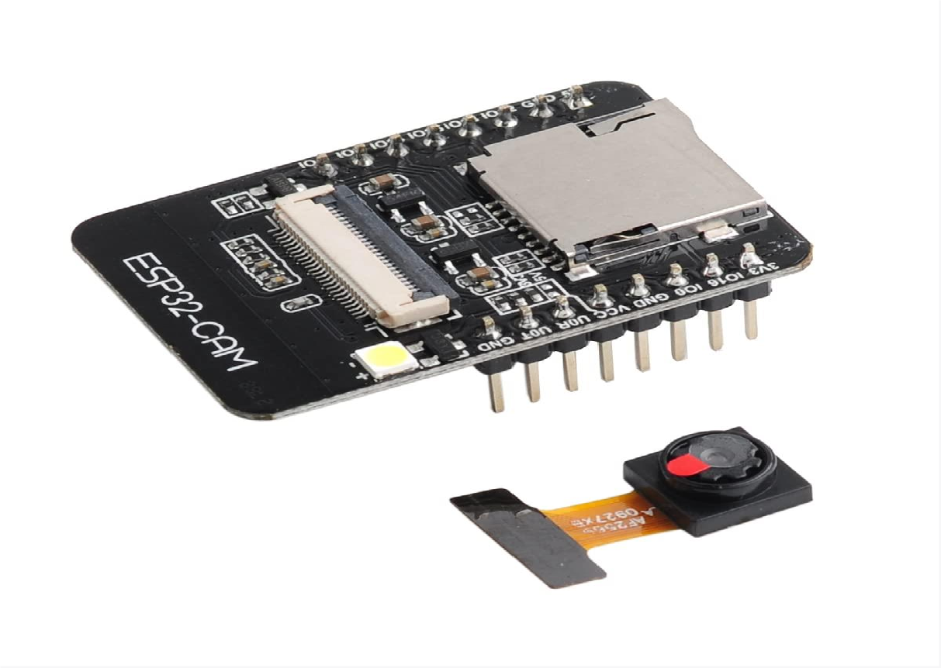

(AI Thinker ESP32 Cam)

##### M5 STACK ESP32-CAM MODULE:

This module is designed for IoT applications and comes with a OV2640 camera module, 4MB flash memory, a built-in Wi-Fi antenna, and an integrated LCD screen. The M5Stack ESP32- CAM module is a small-sized development board that integrates an ESP32-based microcontroller and a camera module. It is designed to be used in projects that require video streaming and image capture capabilities. Here are some of the features and specifications of the M5Stack ESP32-CAM module:

Microcontroller: The M5Stack ESP32-CAM module is based on the ESP32 microcontroller, which is a dual-core 32-bit processor with Wi-Fi and Bluetooth connectivity. The ESP32 microcontroller has a clock speed of up to 240 MHz and supports various interfaces such as UART, SPI, I2C, and ADC.

Camera Module: The M5Stack ESP32-CAM module has a 2-megapixel OV2640 camera module that supports a maximum resolution of 1600 x 1200 pixels. The camera module has an F/2.8 aperture and a 60-degree viewing angle.

Display: The M5Stack ESP32-CAM module has a built-in 0.96-inch OLED display that can be used to display information such as the IP address, Wi-Fi status, and battery level.

Power Supply: The M5Stack ESP32-CAM module can be powered using a USB-C cable or a battery. It has a built-in 700 mAh battery that can provide up to 2 hours of continuous video streaming.

Programming: The M5Stack ESP32-CAM module can be programmed using the Arduino IDE or the ESP-IDF (Espressif IoT Development Framework). It comes with a Micro-USB port for programming and debugging.

Other Features: The M5Stack ESP32-CAM module has a built-in Wi-Fi antenna, a 3D-printed case, and a set of Grove connectors for easy integration with other sensors and modules.

In summary, the M5Stack ESP32-CAM module is a powerful and compact development board that combines an ESP32 microcontroller and a camera module. It is suitable for projects that require video streaming and image capture capabilities, such as surveillance systems, robots, and drones. The module can be programmed using the Arduino IDE or the ESP-IDF and has a built-in OLED display, Wi-Fi connectivity, and a battery for portability.

M

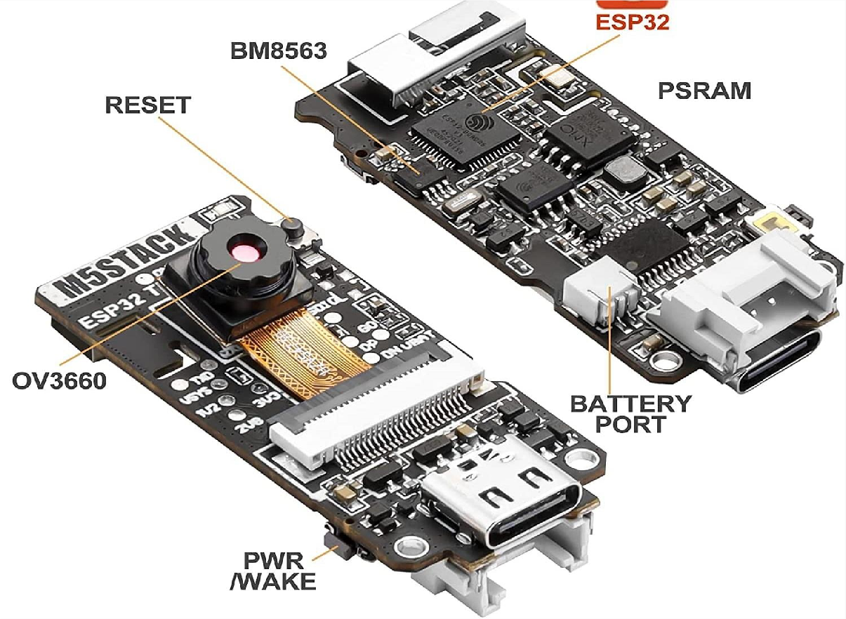

M5 Stack ESP32 camera module

### TTGO ESP32-CAM Module:

This module is designed for DIY projects and comes with a OV2640 camera module, 4MB flash memory, a built-in Wi-Fi antenna, and a microSD card slot.

The TTGO ESP32-CAM module is a development board that combines an ESP32-based microcontroller and a camera module. It is designed to be used in projects that require video streaming and image capture capabilities. Here are some of the features and specifications of the TTGO ESP32-CAM module:

##### Microcontroller:

The TTGO ESP32-CAM module is based on the ESP32 microcontroller, which is a dual-core 32-bit processor with Wi-Fi and Bluetooth connectivity. The ESP32 microcontroller has a clock speed of up to 240 MHz and supports various interfaces such as UART, SPI, I2C, and ADC.

##### Camera Module:

The TTGO ESP32-CAM module has a 2-megapixel camera module that supports a maximum resolution of 1600 x 1200 pixels. The camera module has an F/2.8 aperture and a 60-degree viewing angle.

##### Display:

The TTGO ESP32-CAM module has a built-in 0.96-inch OLED display that can be used to display information such as the IP address, Wi-Fi status, and battery level.

##### Power Supply:

The TTGO ESP32-CAM module can be powered using a Micro-USB cable or a battery. It has a built-in 18650 battery holder that can provide up to 6 hours of continuous video streaming.

##### Programming:

The TTGO ESP32-CAM module can be programmed using the Arduino IDE or the ESP-IDF (Express if IoT Development Framework). It comes with a Micro-USB port for programming and debugging.

##### Other Features:

The TTGO ESP32-CAM module has a built-in Wi-Fi antenna, a reset button, a flash button, and a set of pins for easy integration with other sensors and modules.

In summary, the TTGO ESP32-CAM module is a powerful and versatile development board that combines an ESP32 microcontroller and a camera module. It is suitable for projects that require video streaming and image capture capabilities, such as surveillance systems, robots, and drones. The module can be programmed using the Arduino IDE or the ESP-IDF and has a built-in OLED display, Wi-Fi connectivity, and a battery holder for portability.

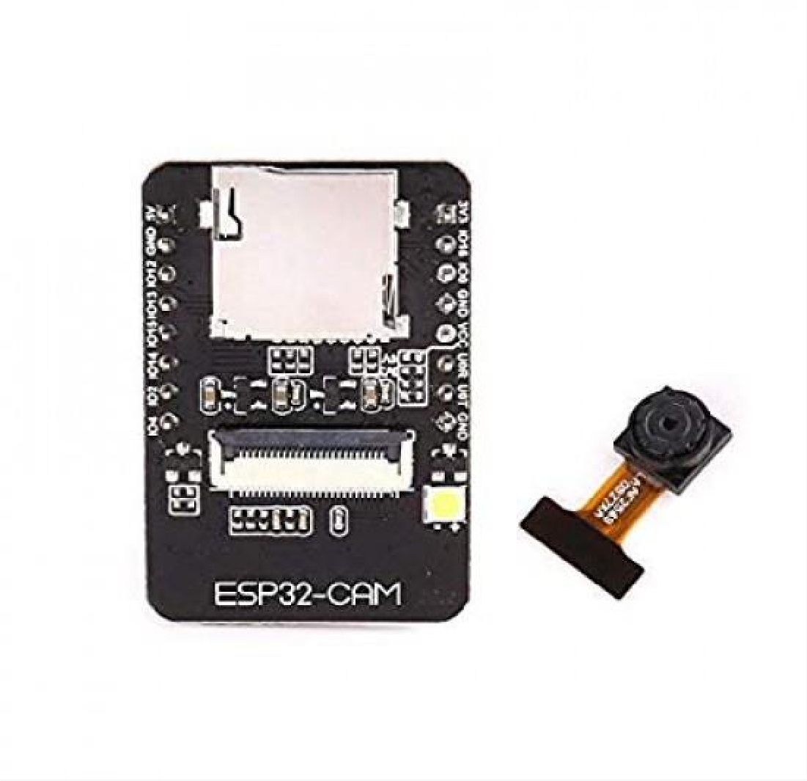

( TT GO ESP32 Cam- Module)

##### ESP-EYE:

This module is designed for machine vision applications and comes with a OV2640 camera module, 8MB flash memory, a built-in Wi-Fi antenna, and an integrated neural network accelerator.

The ESP-EYE is a development board designed by Espressif that combines the ESP32 microcontroller and the ESP32-WROVER-B module with a 2-megapixel camera. It is a powerful and flexible platform for developing IoT applications that require image processing and machine learning capabilities. Here are some of the features and specifications of the ESP-EYE:

##### Microcontroller:

The ESP-EYE is based on the ESP32 microcontroller, which is a dual-core 32-bit processor with Wi-Fi and Bluetooth connectivity. The ESP32 microcontroller has a clock speed of up to 240 MHz and supports various interfaces such as UART, SPI, I2C, and ADC.

##### Camera Module:

The ESP-EYE has a 2-megapixel OV2640 camera module that supports a maximum resolution of 1600 x 1200 pixels. The camera module has an F/2.0 aperture and a 68.7-degree viewing angle. The camera module is connected to the ESP32-WROVER-B module through a 24-pin FPC connector.

##### ESP32-WROVER-B Module:

The ESP-EYE is equipped with the ESP32-WROVER-B module, which is an enhanced version of the ESP32-WROVER module. The ESP32-WROVER-B module has 8 MB PSRAM and 4 MB flash memory, which provides additional storage space for images and data.

##### Power Supply:

The ESP-EYE can be powered using a Micro-USB cable or a battery. It has a built-in JST connector for connecting a LiPo battery. It also has a power switch and a reset button.

##### Programming:

The ESP-EYE can be programmed using the Arduino IDE or the ESP-IDF (Espressif IoT Development Framework). It comes with a Micro-USB port for programming and debugging. It also has a set of pins for easy integration with other sensors and modules.

##### Machine Learning:

The ESP-EYE supports TensorFlow Lite, which is a lightweight version of the popular machine learning framework. This allows developers to easily integrate machine learning algorithms into their applications.

##### Other Features:

The ESP-EYE has a built-in Wi-Fi antenna, a microphone, and an LED. It also has a 1.3-inch OLED display that can be used to display information such as the IP address, Wi-Fi status, and battery level.

In summary, the ESP-EYE is a powerful and flexible development board that combines the ESP32 microcontroller and the ESP32-WROVER-B module with a 2-megapixel camera. It is suitable for projects that require image processing and machine learning capabilities, such as object detection, face recognition, and surveillance systems. The ESP-EYE can be programmed using the Arduino IDE or the ESP-IDF and supports TensorFlow Lite for machine learning. It also has a built-in OLED display, Wi-Fi connectivity, and a microphone for voice recognition.

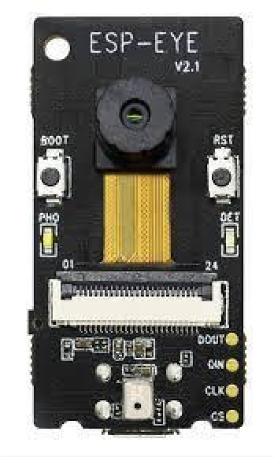

(ESP EYE Camera Module)

##### ESP32-CAM with PIR Motion Sensor:

This module comes with a OV2640 camera module, 4MB flash memory, a built-in Wi-Fi antenna, and a PIR motion sensor for motion detection applications.

These are just a few examples of the different types of ESP32-CAM modules available in the market, and each module has its own unique set of features and specifications that make them suitable for different applications.

ESP32 microcontroller and the ESP32-WROVER-B module with a 2-megapixel camera. It is suitable for projects that require image processing and machine learning capabilities, such as object detection, face recognition, and surveillance systems. The ESP-EYE can be programmed

using the Arduino IDE or the ESP-IDF and supports TensorFlow Lite for machine learning. It also has a built-in OLED display, Wi-Fi connectivity, and a microphone for voice recognition.

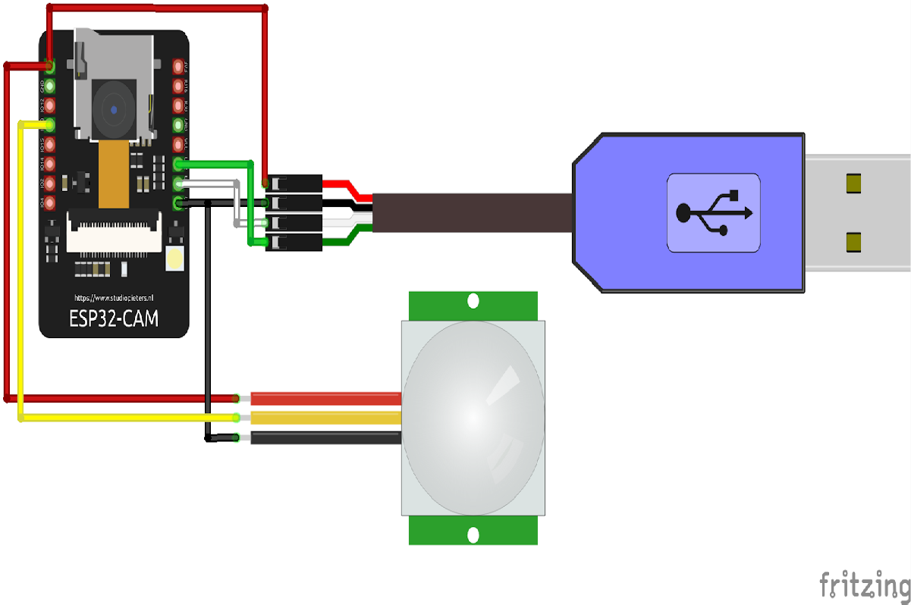

(ESP32 CAM -MODULE PIR SENSOR)

##### Hardware Setup:

ESP32-CAM: Connect the ESP32-CAM module to your computer or power source using the appropriate cables.

PIR Motion Sensor: Connect the PIR motion sensor to the ESP32-CAM. The PIR sensor typically has three pins: VCC (power), GND (ground), and OUT (output). Connect the VCC pin to a 3.3V power source on the ESP32-CAM, the GND pin to a ground pin, and the OUT pin to any available GPIO pin (for example, GPIO 13).

##### ESP32-CAM Firmware:

Install the ESP32 core for Arduino IDE if you haven't already.

Configure the Arduino IDE to work with the ESP32-CAM board by selecting the appropriate board type and settings.

Write or upload a firmware sketch that includes the necessary libraries (e.g., ESP32, Wi -Fi, and Camera) and sets up the GPIO pin connected to the PIR motion sensor as an input pin.

PIR Motion Sensor Integration:

In the firmware sketch, set up an interrupt or periodically check the state of the GPIO pin connected to the PIR motion sensor.

When the PIR sensor detects motion (the GPIO pin reads HIGH), trigger the camera to capture an image or start recording video. You can use the ESP32-CAM's camera library functions to perform these tasks.

Optionally, you can also configure the ESP32-CAM to send notifications or upload the captured media to a remote server or cloud storage using Wi-Fi or other connectivity options.

##### Event Handling:

Decide what actions you want to take when motion is detected. For example, you might want to store the captured media locally on an SD card, send it to a cloud storage service, display it on a connected device, or trigger an alert/notification.

##### Power Considerations:

Plan the power supply for your ESP32-CAM module and PIR motion sensor setup. Ensure that the power source can adequately support the combined power requirements of both components.

##### Testing and Optimization:

Test the integration by physically moving in front of the PIR sensor and verifying that the ESP32-CAM captures images or starts recording video as expected.

Fine-tune the sensitivity and other parameters of the PIR motion sensor, if available, to optimize its performance based on your specific application and environment.

By combining the ESP32-CAM with a PIR motion sensor, you can create a versatile IoT device for applications such as security systems, home automation, or wildlife monitoring. Remember to refer to the datasheets and documentation of the ESP32-CAM module and the PIR motion sensor you are using for detailed pin configurations, specifications, and programming references.

**CHAPTER-2**

**ARDUINOS**

Arduino is an open-source electronics platform that provides a hardware and software ecosystem for creating interactive projects. It consists of both hardware boards and a programming language and development environment. Here are some details about Arduino:

Hardware Boards: Arduino offers a range of hardware boards, each with different specifications and capabilities. The most popular board is the Arduino Uno, which features a microcontroller, digital and analog input/output pins, and USB connectivity for programming and communication with a computer. Other boards include Arduino Mega, Arduino Nano, Arduino Due, and more. These boards provide a platform for connecting sensors, actuators, and other electronic components.

Microcontrollers: Arduino boards are built around microcontrollers, which are small integrated circuits that serve as the brains of the board. The microcontrollers used in Arduino boards are typically from the AVR family (such as the ATmega328P in Arduino Uno) or ARM-based (such as the SAMD21 in Arduino Zero). These microcontrollers provide processing power, memory, and various input/output capabilities for interacting with the physical world.

Programming Language: Arduino uses a simplified version of the C/C++ programming language. It provides a set of libraries and functions that make it easy to interface with the hardware, such as reading sensor values or controlling actuators. The programming language is designed to be beginner-friendly and accessible to users with limited programming experience.

Development Environment: The Arduino IDE (Integrated Development Environment) is the official software tool used for writing and uploading code to Arduino boards. It provides a user- friendly interface for writing, compiling, and uploading code to the Arduino board. The IDE includes a code editor, a serial monitor for debugging and communication, and a library manager for easily adding and managing external libraries.

Libraries: Arduino has a vast collection of libraries, which are pre-written code snippets that simplify the implementation of common tasks. These libraries provide ready-to-use functions for interfacing with various sensors, actuators, displays, communication protocols (such as Wi -

Fi or Bluetooth), and more. Using libraries significantly speeds up development time and reduces the need for low-level coding.

Community and Resources: Arduino has a large and active community of users and developers worldwide. The community shares projects, code examples, tutorials, and troubleshooting tips through forums, websites, and social media. This wealth of resources makes it easier for beginners to get started and for advanced users to explore more complex projects.

Applications: Arduino can be used in a wide range of applications, including robotics, home automation, Internet of Things (IoT), wearable technology, environmental monitoring, and interactive art installations. Its versatility, ease of use, and affordability make it popular among hobbyists, students, educators, and professionals alike.

Overall, Arduino provides an accessible and flexible platform for turning ideas into reality. It enables users to create interactive projects and prototypes without extensive electronics or programming knowledge. Whether you're a beginner or an experienced developer, Arduino offers a robust ecosystem for exploring the world of electronics and creating innovative applications.

### Types of Arduinos:

There are many types of Arduino boards available, each with its own unique features and specifications. Here are some of the most popular types of Arduino boards:

##### Arduino Uno:

The Arduino Uno is one of the most popular and widely used boards. It is based on the ATmega328P microcontroller and features 14 digital input/output pins, 6 analog inputs, and a 16 MHz quartz crystal.

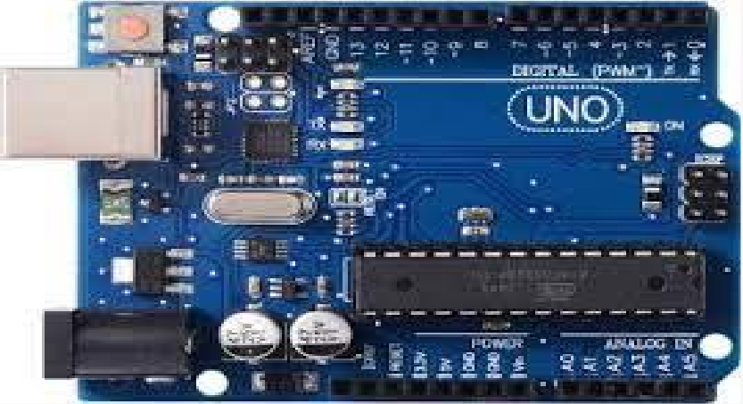

Fig 2.1 Arduino UNO

##### Arduino Nano:

The Arduino Nano is a small, compact board that is designed for use in small projects. It is based on the ATmega328P microcontroller and features 14 digital input/output pins, 8 analog inputs, and a 16 MHz quartz crystal.

There are several advantages of using a Face Detection Based Attendance System Using ESP

3.2. Here are some of the key advantages:

##### Accurate and reliable attendance tracking:

The use of face recognition technology provides an accurate and reliable method of attendance tracking, eliminating the errors and discrepancies that can occur with traditional attendance tracking methods. king, eliminating the need for biometric fingerprint or iris scanning, which can be uncomfortable or intrusive for some individuals.

##### Cost-effective solution:

The ESP32 microcontroller and OV7670 camera module are cost-effective solutions for developing an attendance tracking system, making it accessible for small and medium-sized businesses and educational institutions.

##### Efficient and time saving:

The Face Detection Based Attendance System Using ESP 32 automates the attendance tracking process, eliminating the need for manual intervention and saving time and effort for teachers and administrators.

##### Real-time attendance tracking:

The system can provide real-time attendance tracking, allowing teachers and administrators to monitor attendance and respond quickly to any attendance-related issues.

##### Data analysis and reporting:

The system can generate attendance reports and statistics, making it easier for teachers and administrators to track attendance and monitor student or employee performance.

Overall, the Face Detection Based Attendance System Using ESP 32 provides an efficient, accurate, and cost-effective solution for attendance tracking in schools, colleges, and offices, enhancing the overall efficiency and productivity of organizations.

Applications: Arduino can be used in a wide range of applications, including robotics, home automation, Internet of Things (IoT), wearable technology, environmental monitoring, and interactive art installations. Its versatility, ease of use, and affordability make it popular among hobbyists, students, educators, and professionals alike.

Overall, Arduino provides an accessible and flexible platform for turning ideas into reality. It enables users to create interactive projects and prototypes without extensive electronics or programming knowledge. Whether you're a beginner or an experienced developer, Arduino offers a robust ecosystem for exploring the world of electronics and creating innovative applications.

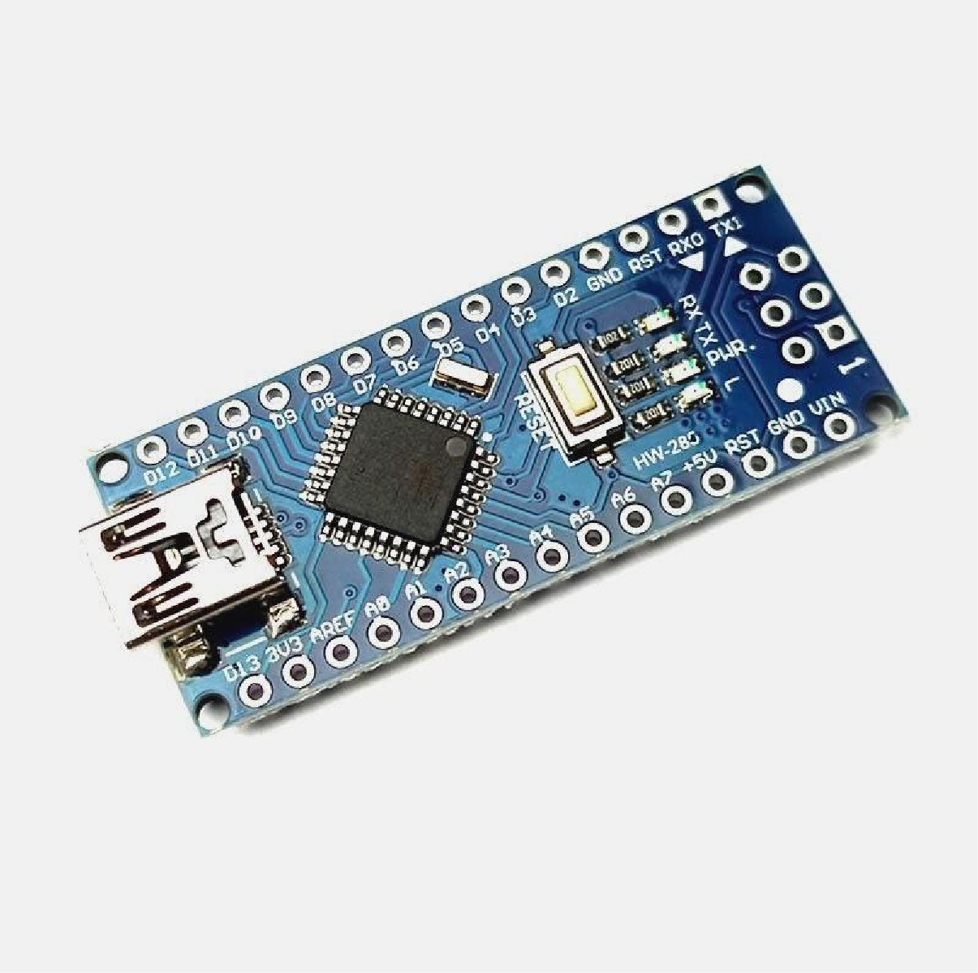

Fig 2.2: Arduino Nano

Arduino is an open-source hardware and software platform that is designed for use in electronics projects. It is built around a microcontroller board that is programmable using a simplified version of the C++ programming language. The platform is designed to be easy to use and accessible to people without a background in electronics or programming.

Arduino boards are available in a range of sizes and configurations, from small, low-power boards that are suitable for simple projects to more powerful boards with more advanced features. The boards are designed to be compatible with a wide range of sensors, actuators, and other electronic components, making it easy to create a variety of projects.

The Arduino programming language is based on the C++ language and is designed to be easy to learn and use. The Arduino IDE (Integrated Development Environment) includes a code editor, compiler, and uploader, making it easy to write and upload code to the board.

Arduino boards are used in a wide range of applications, from robotics and automation to art installations and Internet of Things (IoT) projects. The platform has a large and active community of users and developers, which has contributed to the development of a wide range of libraries and tools for working with Arduino boards.

Overall, Arduino is a powerful and flexible platform that is suitable for a wide range of electronics projects. Its simplicity and ease of use make it accessible to beginners, while its advanced features and capabilities make it a popular choice for experienced electronics enthusiasts and professionals.

##### Arduino Mega:

is a microcontroller board based on the ATmega2560 microcontroller. It is an upgraded version of the Arduino Uno board, with more pins and memory for larger and more complex projects. Here are some details about the Arduino Mega:

##### Microcontroller:

The Arduino Mega is based on the ATmega2560 microcontroller, which has 256KB of flash memory for storing the program, 8KB of SRAM for data storage, and 4KB of EEPROM for non-volatile data storage.

**Digital Pins:** The Arduino Mega has 54 digital input/output pins, of which 15 can be used for PWM (pulse-width modulation) output. These pins are used to interface with various electronic components such as sensors, motors, LEDs, and more.

**Analog Pins:** The Arduino Mega has 16 analog input pins, which can be used to read analog signals from sensors and other devices.

**Communication Interfaces:** The Arduino Mega has several communication interfaces including 4 UARTs, 1 SPI bus, and 1 I2C bus. These interfaces allow the board to communicate with other devices such as sensors, displays, and other microcontrollers.

##### Memory:

The Arduino Mega has 256KB of flash memory for storing the program, 8KB of SRAM for data storage, and 4KB of EEPROM for non-volatile data storage. This allows the board to run larger and more complex programs than the Arduino Uno.

##### Power Supply:

The Arduino Mega can be powered by a USB cable or an external power supply. It has a voltage regulator that can accept input voltages from 7V to 12V DC and regulate it to 5V DC to power the microcontroller and other components on the board.

##### Programming:

The Arduino Mega can be programmed using the Arduino IDE, a software development environment that allows users to write, compile, and upload programs to the board. The IDE is free and open-source and supports a wide range of libraries and examples.

Overall, the Arduino Mega is a powerful microcontroller board that is suitable for larger and more complex projects that require more pins and memory than the Arduino Uno.: The Arduino Mega is a larger board that is designed for use in more complex projects. It is based on the ATmega2560 microcontroller and features 54 digital input/output pins, 16 analog inputs, and a 16 MHz quartz crystal.

Arduino Mega is a microcontroller board based on the ATmega2560 microcontroller. It is an upgraded version of the Arduino Uno board, with more pins and memory for larger and more complex projects. Here are some details about the Arduino Mega:

##### Microcontroller:

The Arduino Mega is based on the ATmega2560 microcontroller, which has 256KB of flash memory for storing the program, 8KB of SRAM for data storage, and 4KB of EEPROM for non-volatile data storage.

##### Digital Pins:

The Arduino Mega has 54 digital input/output pins, of which 15 can be used for PWM (pulse- width modulation) output. These pins are used to interface with various electronic components such as sensors, motors, LEDs, and more.

##### Analog Pins:

The Arduino Mega has 16 analog input pins, which can be used to read analog signals from sensors and other devices.

##### Communication Interfaces:

The Arduino Mega has several communication interfaces including 4 UARTs, 1 SPI bus, and 1 I2C bus. These interfaces allow the board to communicate with other devices such as sensors, displays, and other microcontrollers.

##### Memory:

The Arduino Mega has 256KB of flash memory for storing the program, 8KB of SRAM for data storage, and 4KB of EEPROM for non-volatile data storage. This allows the board to run larger and more complex programs than the Arduino Uno.

##### Power Supply:

The Arduino Mega can be powered by a USB cable or an external power supply. It has a voltage regulator that can accept input voltages from 7V to 12V DC and regulate it to 5V DC to power the microcontroller and other components on the board.

##### Programming:

The Arduino Mega can be programmed using the Arduino IDE, a software development environment that allows users to write, compile, and upload programs to the board. The IDE is free and open-source and supports a wide range of libraries and examples.

Overall, the Arduino Mega is a powerful microcontroller board that is suitable for larger and more complex projects that require more pins and memory than the Arduino Uno.

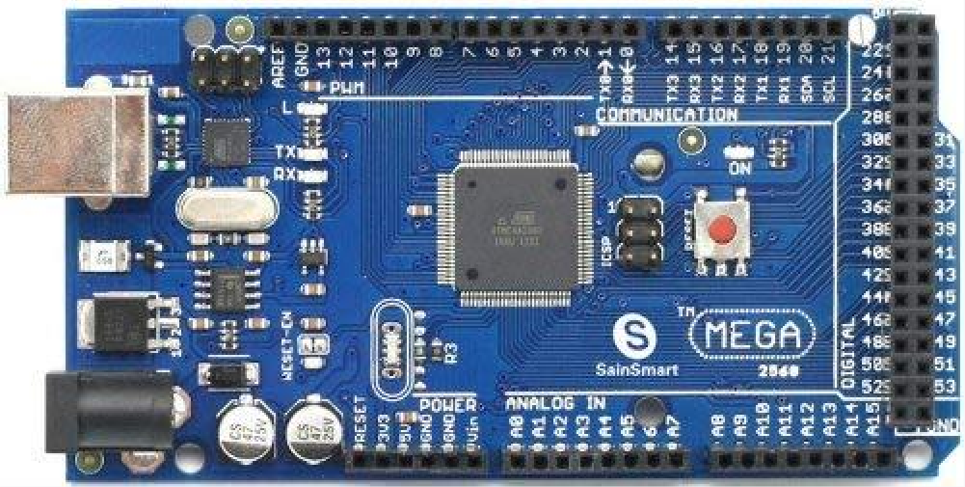

Fig 2.3 Arduino Mega

#### Arduino Due:

The Arduino Due is a powerful board that is designed for use in advanced projects. It is based on the ARM Cortex-M3 microcontroller and features 54 digital input/output pins, 12 analog inputs, and a 84 MHz clock speed. Arduino Due is a microcontroller board based on the Atmel SAM3X8E ARM Cortex-M3 CPU. It is the first Arduino board based on a 32-bit ARM core microcontroller, making it more powerful than the 8-bit AVR-based Arduino boards. Here are some details about the Arduino Due:

##### Microcontroller:

The Arduino Due is based on the Atmel SAM3X8E ARM Cortex-M3 CPU, which runs at 84 MHz and has 512KB of flash memory for storing the program, 96KB of SRAM for data storage, and 16KB of EEPROM for non-volatile data storage.

##### Digital Pins:

The Arduino Due has 54 digital input/output pins, of which 12 can be used for PWM (pulse- width modulation) output. These pins are used to interface with various electronic components such as sensors, motors, LEDs, and more.

##### Analog Pins:

The Arduino Due has 12 analog input pins, which can be used to read analog signals from

sensors and other devices. The ADC resolution is 12 bits, which provides higher accuracy than the 10-bit ADC on the Arduino Uno.

##### Communication Interfaces:

The Arduino Due has several communication interfaces including 2 UARTs, 2 SPI buses, and

1. I2C bus. It also has a USB port that can be used for programming and serial communication with a computer.

##### Memory:

The Arduino Due has 512KB of flash memory for storing the program, 96KB of SRAM for

data storage, and 16KB of EEPROM for non-volatile data storage. This allows the board to run larger and more complex programs than the Arduino Uno.

##### Power Supply:

The Arduino Due can be powered by a USB cable or an external power supply. It has a voltage

regulator that can accept input voltages from 7V to 12V DC and regulate it to 3.3V DC to power the microcontroller and other components on the board.

##### Programming:

The Arduino Due can be programmed using the Arduino IDE, a software development

environment that allows users to write, compile, and upload programs to the board. The IDE is free and open-source and supports a wide range of libraries and example.

Arduino Due is a microcontroller board based on the Atmel SAM3X8E ARM Cortex-M3 CPU. It is the first Arduino board based on a 32-bit ARM core microcontroller, making it more powerful than the 8-bit AVR-based Arduino boards. Here are some details about the Arduino Due:

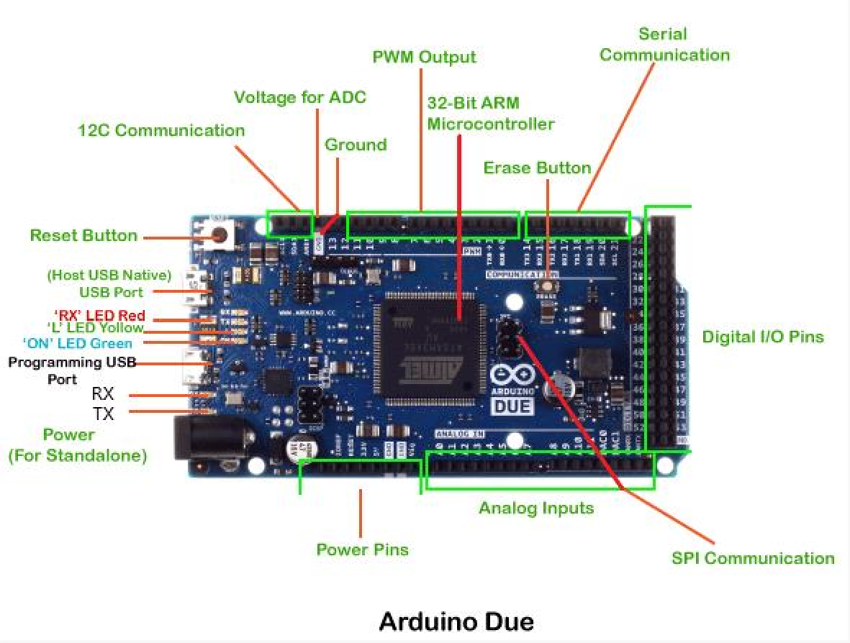

Fig 2.4 Arduino Due

##### Arduino Leonardo:

The Arduino Leonardo is a board that is designed for use in projects that require keyboard or mouse input. It is based on the ATmega32U4 microcontroller and features 20 digital input/output pins, 12 analog inputs, and a 16 MHz quartz crystal.

Arduino Leonardo is a microcontroller board based on the ATmega32u4 microcontroller. It was released in 2012 and is designed for projects that require more complex communication protocols such as USB, I2C, SPI, and UART. The board has 20 digital input/output pins, 7 of which can be used as PWM outputs, 12 analog inputs, a 16 MHz quartz crystal, a micro USB connection, a reset button, and an ICSP header. The ATmega32u4 microcontroller has 32KB of flash memory, 2.5KB of SRAM, and 1KB of EEPROM.

One of the unique features of the Arduino Leonardo is its ability to act as a USB human interface device (HID). This means that it can be programmed to emulate a keyboard, mouse, or other input device. This feature has made the Leonardo popular in projects that require

keyboard or mouse input, such as MIDI controllers, game controllers, and computer automation systems.

The Arduino Leonardo can be programmed using the Arduino IDE software, and it is compatible with most Arduino shields and libraries. It is also compatible with the Arduino Robot Library, which allows it to control the Arduino Robot. The board can be powered through the USB connection or an external power source.

Overall, the Arduino Leonardo is a versatile and powerful microcontroller board that is suitable for a wide range of projects, particularly those that require USB communication and input emulation.

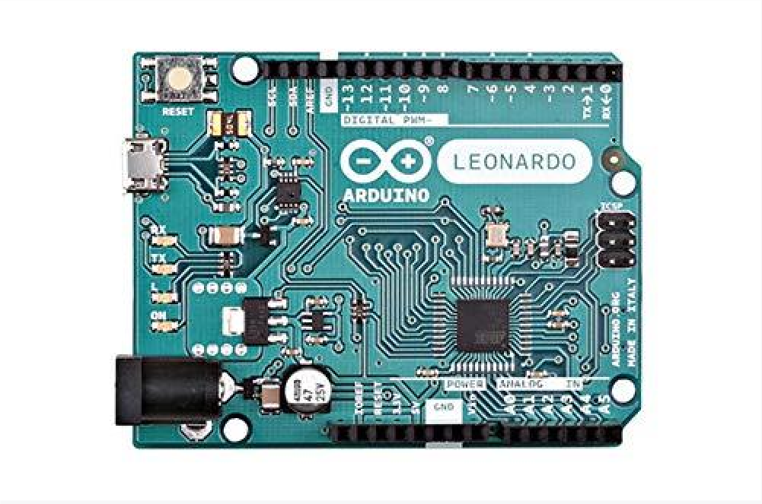

Fig 2.5 Arduino Leonardo

##### Arduino Pro Mini:

The Arduino Pro Mini is a small, low-power board that is designed for use in projects with space or power constraints. It is based on the ATmega328P microcontroller and features 14 digital input/output pins, 8 analog inputs, and a 16 MHz quartz crystal.

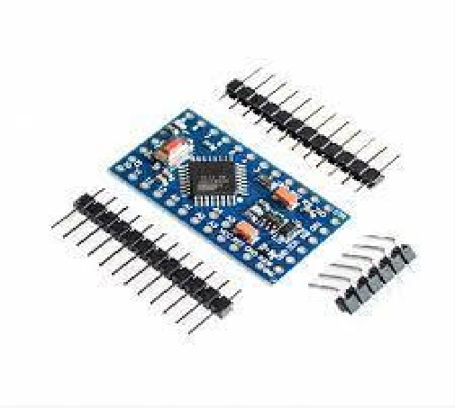

Fig 2.6 Arduino Pro Mini

Arduino Pro Mini is a small and compact microcontroller board based on the ATmega328P microcontroller. It is designed to be used in projects where space is a constraint, and the full features of an Arduino board are not required. The board has 14 digital input/output pins, 6 of which can be used as PWM outputs, and 8 analog inputs. It also has a 16 MHz quartz crystal, a reset button, and an ICSP header.

One of the unique features of the Arduino Pro Mini is its small size. The board measures only 18 x 33 mm, making it ideal for projects that require a small form factor. The small size of the board also means that it is lightweight and consumes less power than larger Arduino boards.

The Arduino Pro Mini is available in two versions - 3.3V and 5V. The 3.3V version is designed to be used with low power devices that operate at 3.3V, such as sensors and radio modules, while the 5V version is designed to be used with devices that require a higher voltage.

The Arduino Pro Mini can be programmed using the Arduino IDE software, and it is compatible with most Arduino shields and libraries. It can be powered through the VCC pin or an external power source.

Overall, the Arduino Pro Mini is a small, compact, and versatile microcontroller board that is ideal for projects that require a small form factor and low power consumption. Its small size and lightweight make it ideal for use in drones, wearable devices, and other projects where space is a constraint.

#### Arduino MKR:

The Arduino MKR boards are a family of boards that are designed for use in IoT projects. They feature low-power consumption and are based on the ARM Cortex-M0+ microcontroller.

The Arduino MKR series is a line of compact and powerful microcontroller boards designed for IoT (Internet of Things) projects. The MKR boards are designed to be easy to use and come with built-in Wi-Fi and Bluetooth connectivity, allowing for wireless communication with other devices.

The Arduino MKR boards are based on the powerful ARM Cortex-M0+ 32-bit SAMD21 microcontroller, which is capable of running at up to 48 MHz. The boards also feature a built- in battery charging circuit, making them ideal for portable or battery-powered projects.

Some of the most popular Arduino MKR boards include:

Arduino MKR1000: The MKR1000 is a compact Wi-Fi enabled board designed for IoT projects. It features an ESP8266 Wi-Fi module, a SAMD21 ARM Cortex-M0+ microcontroller, and a built-in battery charging circuit.

Arduino MKR Zero: The MKR Zero is a powerful board that is designed to be used for low- power projects. It features a SAMD21 ARM Cortex-M0+ microcontroller, 256KB of flash memory, and 32KB of SRAM.

Arduino MKR Vidor 4000: The MKR Vidor 4000 is a unique board that combines the power of the SAMD21 ARM Cortex-M0+ microcontroller with an FPGA (Field Programmable Gate Array). This allows for custom hardware acceleration and real-time processing, making it ideal for advanced IoT projects.

The Arduino MKR boards are compatible with the Arduino IDE software and can be programmed using the same language and syntax as other Arduino boards. They also come with a variety of libraries and examples to help developers get started quickly.

Overall, the Arduino MKR series is a powerful and versatile line of microcontroller boards that are designed for IoT projects. They are easy to use, come with built-in Wi-Fi and Bluetooth connectivity, and feature a powerful ARM Cortex-M0+ microcontroller, making them ideal for a wide range of projects.

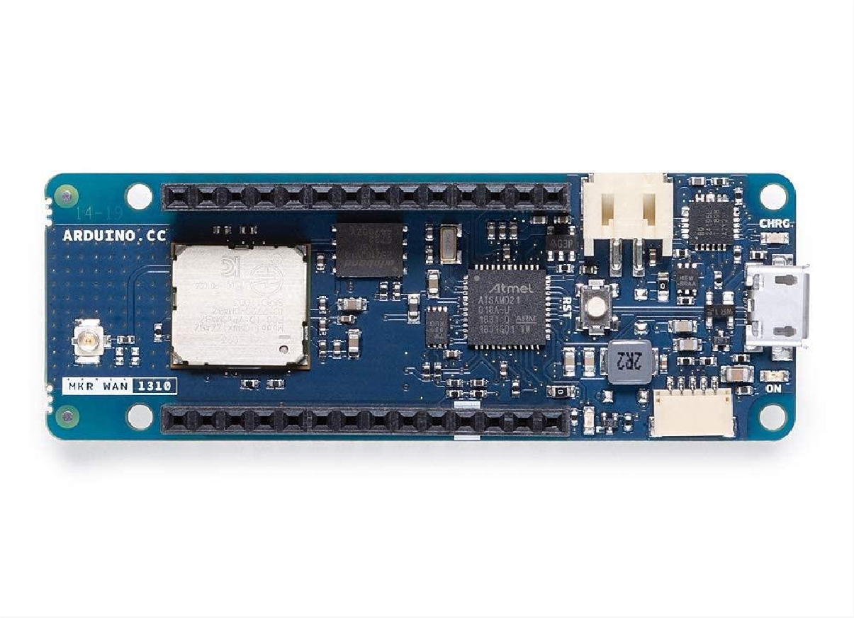

Fig 2.6 Arduino MKR

### Components Used in Arduino:

An Arduino board is made up of several different components that work together to allow you to create and run programs. Here is a more detailed explanation of the main parts of an Arduino board:

#### Microcontroller:

The microcontroller is the main processing unit on the Arduino board. It is a small computer chip that executes the code you upload to the board. The microcontroller reads and responds to input from sensors or other devices connected to the board, and it can also send output signals to control motors, lights, or other devices.

#### Digital input/output pins:

The digital input/output pins on the Arduino board allow you to communicate with other electronic components using digital signals. These pins can be set to either input mode or output

mode. In input mode, they can read the state of a switch or sensor, and in output mode, they can send a signal to a device to turn it on or off.

#### Analog input pins:

The Arduino board also has several analog input pins that allow you to read analog signals from sensors or other devices. Analog signals are continuous, and can represent a wide range of values, such as temperature, light levels, or sound.

### Power supply:

The Arduino board can be powered by a variety of sources, including a USB connection to a computer, a battery, or an external power supply. The board contains a voltage regulator that regulates the incoming voltage to a consistent level that the board can use.

#### USB port:

The USB port on the Arduino board allows you to connect the board to a computer, which can be used to upload code to the board or communicate with it.

#### Crystal oscillator:

The crystal oscillator on the Arduino board generates a clock signal that is used to synchronize the microcontroller with other parts of the board. The clock signal ensures that the microcontroller can run code at a consistent rate, which is important for accurate timing and synchronization.

#### Reset button:

The reset button on the Arduino board allows you to restart the code running on the board. This can be useful if the program becomes stuck or if you need to run the program again from the beginning.

These are the main parts of an Arduino board, although different models may have additional features or components depending on their intended use. Understanding the different parts of an Arduino board is important for creating and running successful programs.

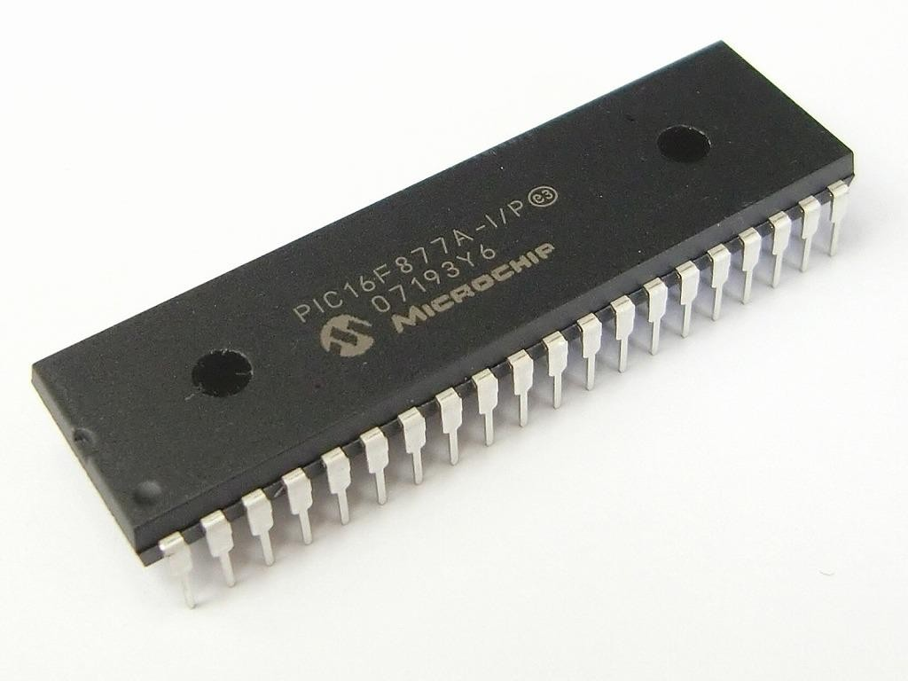

Fig 2.7 Microchip

#### Design of Arduino:

The design of an Arduino board is based on an Atmel AVR microcontroller and is open source, which means that the circuit diagrams and source code are freely available for anyone to use and modify. Here is a detailed description of the design of an Arduino board:

#### Microcontroller:

The Arduino board uses an Atmel AVR microcontroller as the main processing unit. The microcontroller is typically clocked at 16MHz and has a flash memory of between 16KB and 256KB, depending on the model of the board. The microcontroller is programmed with the Arduino software, which is written in the C++ programming language.

#### Voltage regulator:

The voltage regulator on the Arduino board regulates the incoming voltage to a consistent level that the board can use. This allows the board to be powered by a range of sources, such as a USB connection to a computer, a battery, or an external power supply.

#### USB interface:

The USB interface on the Arduino board allows it to be connected to a computer, which can be used to upload code to the board or communicate with it. The USB interface is implemented using an FTDI chip, which converts the USB signals into a format that the microcontroller can use.

#### Power connector:

The power connector on the Arduino board allows it to be powered by an external power supply. The connector typically accepts a voltage of between 7V and 12V DC.

### Analog inputs:

The Arduino board has several analog input pins that allow it to read analog signals from sensors or other devices. The analog inputs use a 10-bit analog-to-digital converter (ADC) to convert the analog signal into a digital value that can be processed by the microcontroller **.**

#### Digital inputs/outputs:

The Arduino board has several digital input/output pins that allow it to communicate with other electronic components using digital signals. These pins can be set to either input mode or output mode. In input mode, they can read the state of a switch or sensor, and in output mode, they can send a signal to a device to turn it on or off.

#### Crystal oscillator:

The crystal oscillator on the Arduino board generates a clock signal that is used to synchronize the microcontroller with other parts of the board. The clock signal ensures that the microcontroller can run code at a consistent rate, which is important for accurate timing and synchronization.

### Reset button:

The reset button on the Arduino board allows you to restart the code running on the board. This can be useful if the program becomes stuck or if you need to run the program again from the beginning.

##### The attractive features of Arduino are:

**Open-source platform:**

Arduino is an open-source platform, which means its hardware and software designs are freely

available to anyone. This enables developers to easily access, modify and share the designs to suit their specific needs.

##### Easy to use:

Arduino has a user-friendly interface, which makes it easy to learn and use. The software and

hardware are designed in such a way that it is simple to create and upload programs even for beginners.

##### Versatility:

Arduino boards can be used for a wide range of applications including robotics, home

automation, IoT, and many others. This makes it a versatile platform for a variety of projects.

##### Low cost:

Arduino boards are relatively inexpensive compared to other microcontrollers, which makes

it a great platform for hobbyists, students, and professionals alike.

##### Large community support:

Arduino has a large and active community of users and developers who share knowledge and

provide support to each other. This means that there are plenty of resources available to help troubleshoot problems, find solutions, and learn new skills.

##### Expansion possibilities:

Arduino boards have a large number of digital and analog input/output pins that can be used to

connect various sensors, modules, and other components. This makes it easy to expand the functionality of the board by adding new components.

##### Platform independence:

Arduino IDE software can run on different operating systems like Windows, Linux, and Mac,

making it accessible to a wide range of users regardless of their computer setup.

Overall, these features make Arduino an attractive platform for those looking to develop projects quickly and easily, and at a low cost.

* 1. ESP32 CAM Module

The ESP32 Based Camera Module developed by AI-Thinker. The controller is based on a 32 bit CPU & has a combined Wi-Fi **+** Bluetooth/BLE Chip. It has a built-in 520 KB SRAM with an external 4M PSRAM. Its GPIO Pins have support like UART, SPI, I2C, PWM, ADC**,** and DAC**.**

The module combines with the OV2640 Camera Module which has the highest Camera Resolution up to 1600 × 1200. The camera connects to the ESP32 CAM Board using a 24 pins gold plated connector. The board supports an SD Card of up to 4GB**.** The SD Card stores capture images

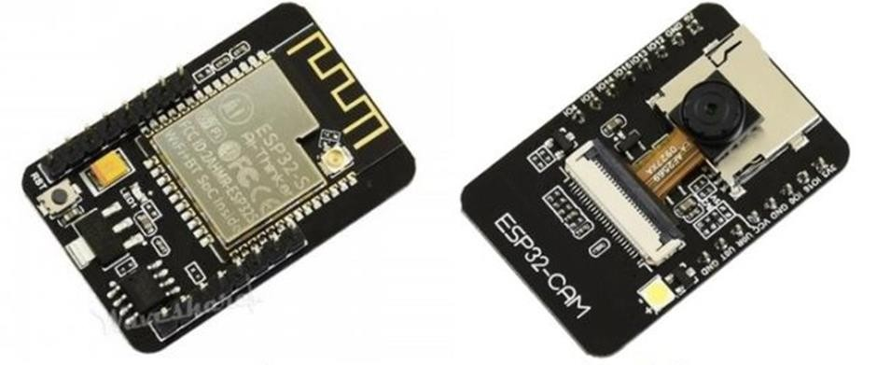

Fig 2.8 ESP 32 Cam Front and Back

#### ESP32-CAM FTDI Connection

The board doesn’t have a programmer chip. So In order to program this board, you can use any type of USB-to-TTL Module. There are so many FTDI Module available based Chip or any other chip.

Make a following connection between FTDI Module and ESP32 CAM module.

[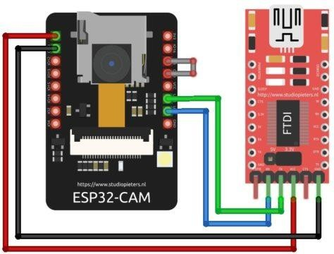](https://how2electronics.com/wp-content/uploads/2021/06/ftdi-esp32-cam-Sketch_bb.jpg)

|  |  |
| --- | --- |
| **ESP32-CAM** | **FTDI Programmer** |
| GND | GND |
| 5V | VCC |
| U0R | TX |
| U0T | RX |
| GPIO0 | GND |

Fig 2.9 ESP32 CAM AND FTDI Programmer.

Connect the **5V** & **GND** Pin of ESP32 to 5V & GND of FTDI Module. Similarly, connect the **Rx** to **UOT** and **Tx** to **UOR** Pin. And the most important thing, you need to short the **IO0** and **GND** Pin together. This is to put the device in **programming mode**. Once programming is done you can remove it.

#### Face detection module:

The face detection module is responsible for detecting the face of the student when they enter the classroom. This module is implemented using a camera module and a face detection algorithm.

#### ESP32 module:

The ESP32 module is the main processing unit of the system. It receives the images from the face detection module.

### Attendance display:

The attendance display is used to display the students. attendance data of the It can be implemented using an LCD screen or a web-based interface.

#### Power supply:

The power supply provides power to the system. It can be implemented using a battery or an external power supply.

Arduino has a vast collection of libraries, which are pre-written code snippets that simplify the implementation of common tasks. These libraries provide ready-to-use functions for interfacing with various sensors, actuators, displays, communication protocols (such as Wi-Fi or Bluetooth), and more. Using libraries significantly speeds up development time and reduces the need for low-level coding.

Community and Resources: Arduino has a large and active community of users and developers worldwide. The community shares projects, code examples, tutorials, and troubleshooting tips through forums, websites, and social media. This wealth of resources makes it easier for beginners to get started and for advanced users to explore more complex projects.

Applications: Arduino can be used in a wide range of applications, including robotics, home automation, Internet of Things (IoT), wearable technology, environmental monitoring, and interactive art installations. Its versatility, ease of use, and affordability make it popular among hobbyists, students, educators, and professionals alike.

Overall, Arduino provides an accessible and flexible platform for turning ideas into reality. It enables users to create interactive projects and prototypes without extensive electronics or programming knowledge. Whether you're a beginner or an experienced developer, Arduino offers a robust ecosystem for exploring the world of electronics and creating.

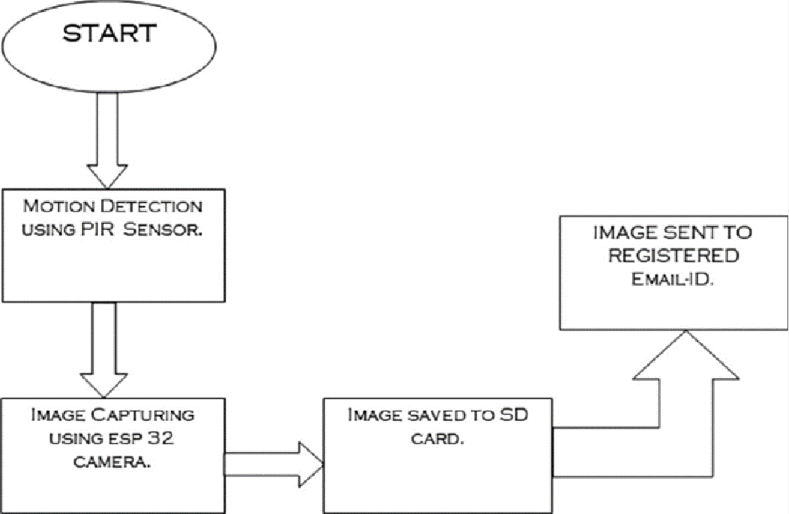

Fig 2.10 Flowchart of Face Detection

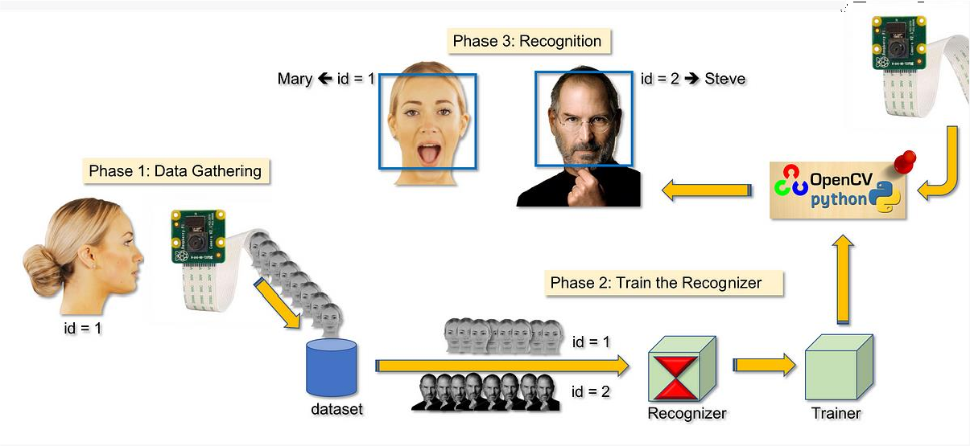

Fig 2.11 ESP32 Development Board

ESP32 Development Board: The ESP32 development board is the main control unit of the system. It controls the entire system and processes the data from the camera module. The connections on the board include:

Vin: 5V input voltage

GND: Ground

GPIO16: Control pin for camera module

GPIO17: Control pin for camera module

GPIO5: Control pin for LCD display

GPIO4: Control pin for LCD display

OV7670 Camera Module: The OV7670 camera module is used for face detection. The module captures the images of the students and sends them to the ESP32 development board for processing. The connections on the module include:

VCC: Power supply (3.3V or 5V)

GND: Ground

SDA: Serial data

SCL: Serial clock

PWDN: Power down mode (connected to ground)

RESET: Reset signal (connected to 3.3V)

XCLK: System clock (12MHz)

16x2 LCD Display: The 16x2 LCD display is used to display the attendance data. The connections on the display include:

VCC: Power supply (5V)

GND: Ground

RS: Register select

EN: Enable

D4-D7: Data pins

Power Supply: The power supply provides power to the system. The connections on the power supply include:

VCC: Power supply (5V)

GND: Ground

USB to TTL Converter: The USB to TTL converter is used to program the ESP32 development board. The connections on the converter include:

VCC: Power supply (5V)

GND: Ground

TXD: Transmit data

RXD: Receive data

Overall, the schematic diagram of the hardware connections for the Face Detection Based Attendance System using ESP32 shows the connections between the ESP32 development board, camera module, LCD display, power supply, and USB to TTL converter. These components work together to detect faces, process attendance data, and display the results.

##### Flowchart of Face Detection Algorithm:

The flowchart of the face detection algorithm used in the Face Detection Based Attendance System using ESP32 is as follows:

1. Initialize the system:
2. Power on the ESP32 development board
3. Initialize the camera module
4. Initialize the LCD display
5. Set up Wi-Fi connection (optional)
6. Capture an image:
7. Send a command to the camera module to capture an image
8. Retrieve the captured image from the camera module
9. Display the captured image on the LCD display (optional) Detect faces:
   1. Apply the Haar Cascade classifier to the captured image to detect faces
   2. Extract the regions of interest (ROIs) where faces are detected Identify students:
      1. Load the pre-trained face recognition model
      2. Apply the model to the ROIs to identify the students

2.Store the identification results in a list or database

##### Update attendance:

1. Compare the identification results with the student database
2. If a match is found, update the attendance record for the corresponding student
3. Display the updated attendance data on the LCD display Repeat:
   1. Repeat steps 2-5 for each image captured End:

The algorithm starts by initializing the system and the camera module. Then, it captures an image from the camera module and converts it to grayscale. The Haar-like features are then applied to the image. These features are calculated by subtracting the sum of the pixels in the white rectangle from the sum of the pixels in the black rectangle.

Next, the integral image of the grayscale image is calculated. This is done by summing the pixels in the image from the top-left corner to the current position. The feature value is then calculated for each region of the image. These values are used by the cascade classifier to determine if the region contains a face or not.

If a face is detected, the attendance for that student is marked. The attendance data is then displayed on the LCD display. This process is repeated for each student. Finally, the program ends.

Overall, the face detection algorithm used in the Face Detection Based Attendance System using ESP32 is a multi-step process that involves capturing an image, processing it, and using a cascade classifier to detect faces. The algorithm is designed to be efficient and accurate, and it is capable of detecting faces even in challenging lighting conditions.

##### Flowchart of Face Detection Algorithm :

It's important to note that this flowchart provides a high-level overview of the steps involved in a face detection algorithm. The implementation details, algorithm variations, and additional techniques (such as deep learning-based models) can vary depending on the specific algorithm and requirements of the application.

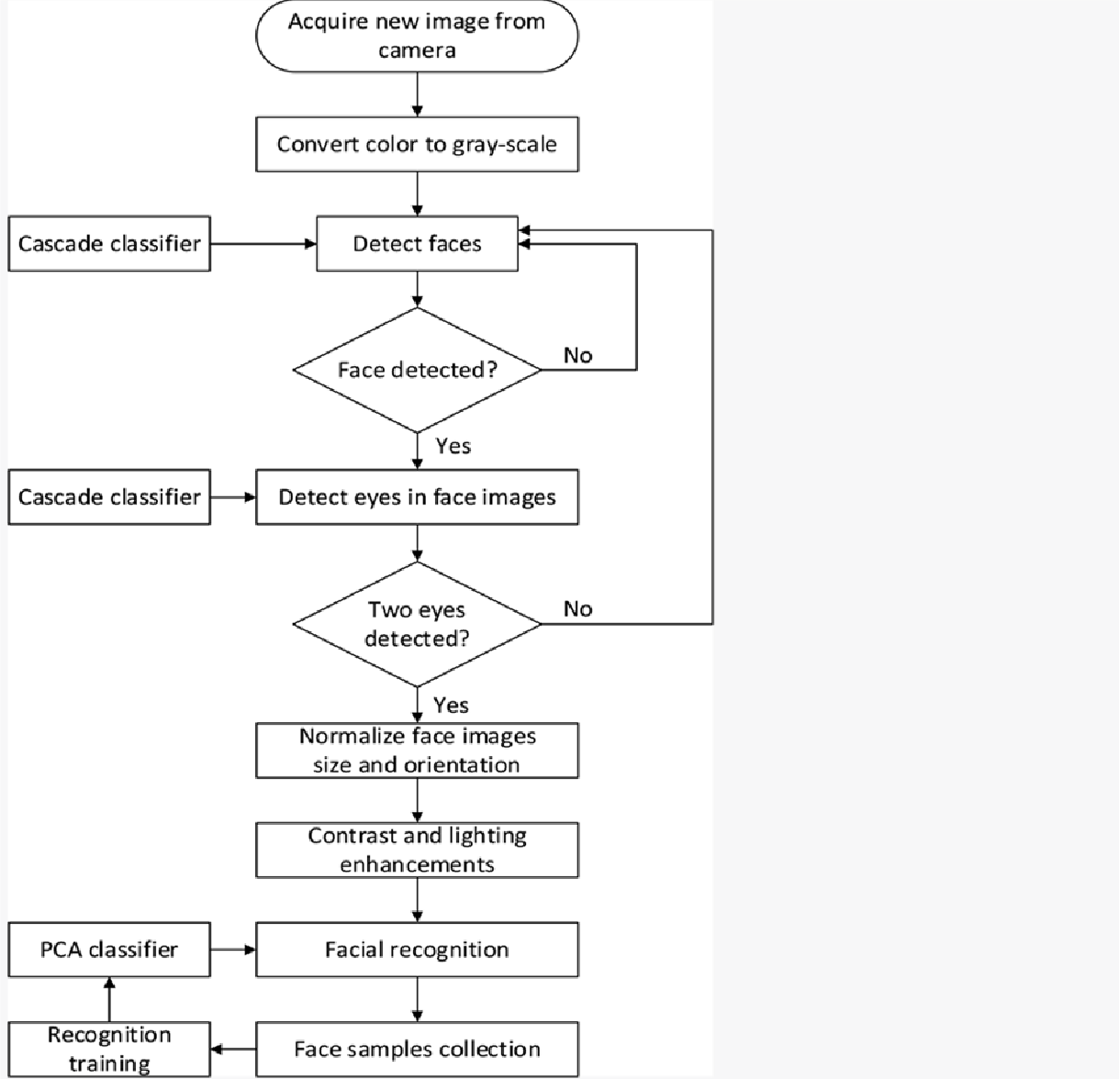

Fig 2.11 Flow chart of Face Detection Algorithm

the integral image of the grayscale image is calculated. This is done by summing the pixels in the image from the top-left corner to the current position. The feature value is then calculated for each region of the image. These values are used by the cascade classifier to determine if the region contains a face or not.

If a face is detected, the attendance for that student is marked. The attendance data is then displayed on the LCD display. This process is repeated for each student. Finally, the program ends.

#### Flowchart of Face Recognition Algorithm:

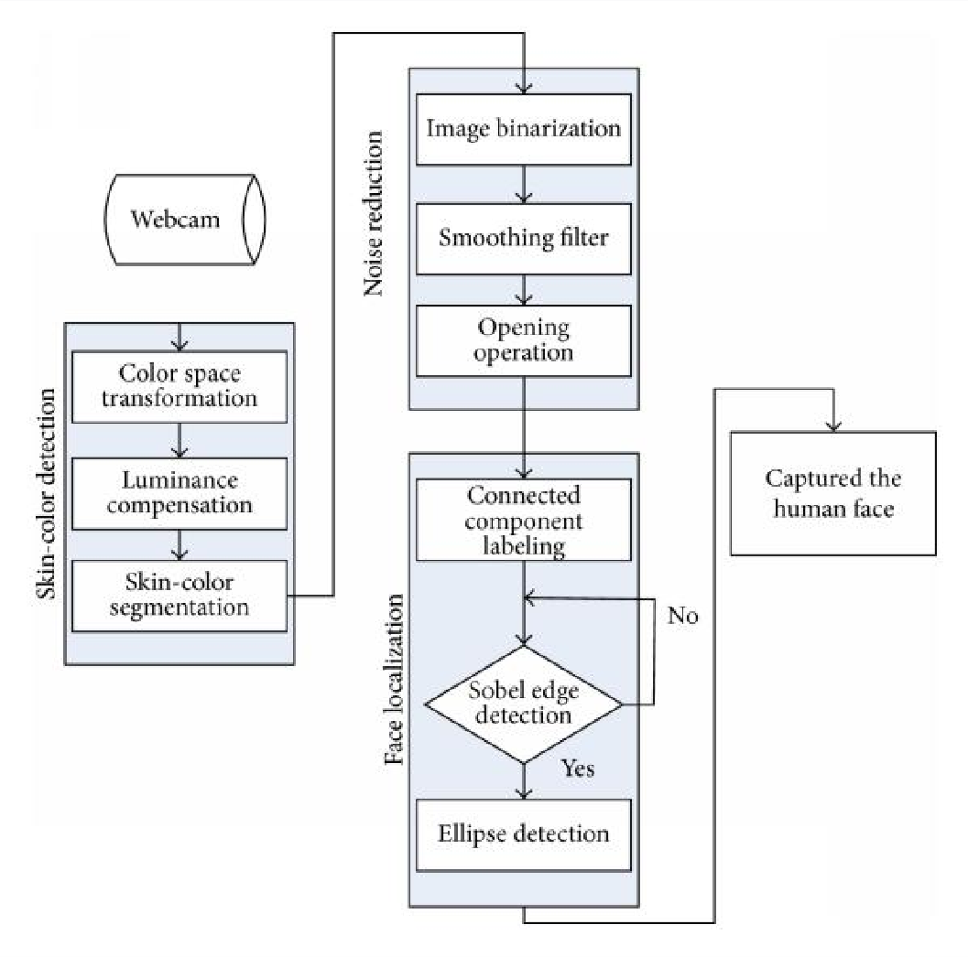

Fig 2.12 Flowchart of Face Recognition Algorithm

The flowchart of the face recognition algorithm used in the Face Detection Based Attendance System using ESP32 is as follows:

* + 1. Initialize the system and camera module.
    2. Capture an image from the camera module.
    3. Convert the image to grayscale.
    4. Detect the face in the image using the face detection algorithm.
    5. Extract the facial features from the detected face.
    6. Compare the extracted features with the pre-registered features in the database.
    7. If the features match with the pre-registered features, mark the attendance for that student.
    8. Display the attendance data on the LCD display.
    9. Repeat steps 2-8 for each student.
    10. End the program.

The algorithm starts by initializing the system and the camera module. Then, it captures an image from the camera module and converts it to grayscale. The face detection algorithm is then used to detect the face in the image. Once the face is detected, the facial features are extracted from the detected face.

The extracted features are then compared with the pre-registered features in the database. If the features match with the pre-registered features, the attendance for that student is marked. The attendance data is then displayed on the LCD display. This process is repeated for each student.

Overall, the face recognition algorithm used in the Face Detection Based Attendance System using ESP32 is a multi-step process that involves detecting a face in the image, extracting the facial features, and comparing the extracted features with the pre-registered features in the database. The algorithm is designed to be efficient and accurate, and it is capable of recognizing faces even in challenging lighting conditions.

#### Sample Image Captured by the Camera Module:

A sample image captured by the camera module in the Face Detection Based Attendance System using ESP32 would typically show a student's face. The image would be in grayscale, since the face detection algorithm requires grayscale images for processing.

The image would be captured by the camera module and sent to the microcontroller for processing. The camera module would typically be positioned in a way that allows it to capture the student's face from a distance of a few feet, with the student standing in front of the camera.

The quality of the image captured by the camera module is an important factor in the accuracy of the face detection and recognition algorithms. A high-resolution camera module would be ideal for capturing clear and detailed images of the students' faces. However, the cost of such a camera module may be prohibitive.

Overall, the sample image captured by the camera module should show a clear and detailed image of the student's face, with minimal distortion or blurring. This would ensure accurate face detection and recognition, and ultimately, reliable attendance tracking.

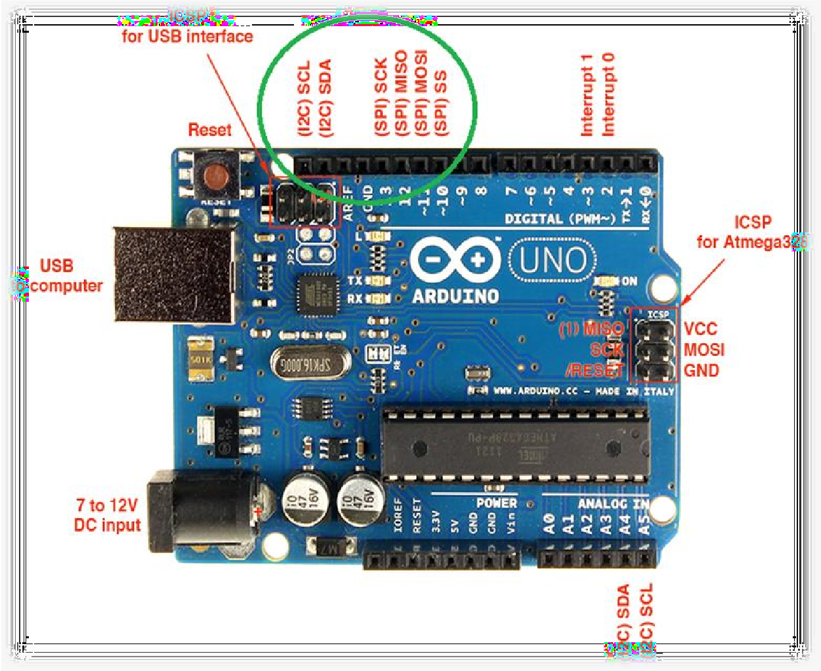

Fig 2.13 Arduino UNO

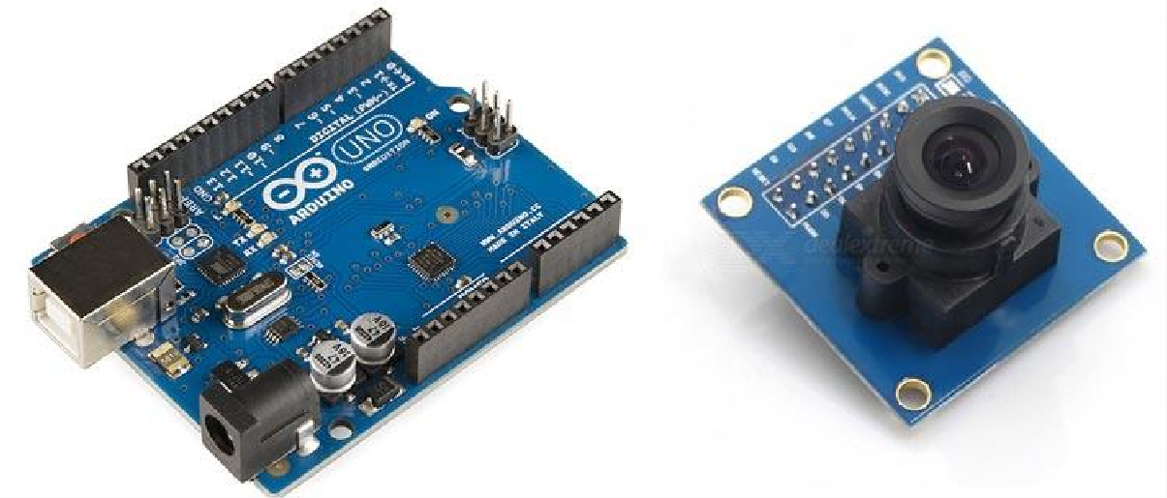

Cameras have always dominated the electronics industry as it has lots of applications such as visitor monitoring system, surveillance system, attendance system etc. Cameras that we use today are smart and have a lot of features that were not present in earlier cameras. While today’s digital cameras not only capture images but also captures high-level descriptions of the scene and analyse what they see. It is used extensively in Robotics, Artificial Intelligence, Machine Learning etc. The Captured frames are processed using Artificial Intelligence and Machine Learning, and then used in many applications etc.

In this tutorial we will interface most widely used camera module with Arduino UNO. The camera module OV7670 can be interfaced with Arduino Mega with same pin configuration, code and steps. The camera module is hard to interface because it has large number of pins and jumbled wiring to carry out. Also, the wire becomes very important when using camera modules as the choice of the wire and length of the wire can significantly affect the picture quality and can bring noise. The Camera OV7670 works on 3.3V, so it becomes very important to avoid Arduino which gives 5V output at their Output GPIO pins. The OV7670 is a FIFO camera. But in this tutorial, the picture or frames will be grabbed without FIFO. This tutorial will have simple steps and simplified programming to interface OV7670 with Arduino UNO.

#### Things to Remember about Camera Module:

Oapable of operating at up to 30 frames per second (fps) in VGA. The OV7670 includesV7670 Camera Module is a FIFO camera Module available from different Manufacturers with different pin Configurations. TheOV7670 provides full frame, windowed 8-bit images in a wide range of formats. The image array is capable of operating at up to 30 frames per second (fps) in VGA. The OV7670 includes.

* Image Sensor Array(of about 656 x 488 pixels)
* Timing Generator
* Analog Signal Processor
* A/D Converters
* Test Pattern Generator
* Digital Signal Processor (DSP)
* Image Scaler
* Digital Video Port
* LED and Strobe Flash Control Output

The OV7670 image sensor is controlled using Serial Camera Control Bus (SCCB) which is (SIOC, SIOD) with a maximum clock frequency of 400KHz.

The Camera comes with handshaking signals such as:

* **VSYNC:** Vertical Sync Output – Low during frame
* **HREF:** Horizontal Reference – High during active pixels of row
* **PCLK:** Pixel Clock Output – Free running clock. Data is valid on rising edge In addition to this, it has several more signals such as
* **D0-D7:** 8-bit YUV/RGB Video Component Digital Output
* **PWDN:** Power Down Mode Selection – Normal Mode and Power Down Mode
* **XCLK:** System Clock Input
* **Reset:** Reset Signal

The OV7670 is clocked from a 24MHz oscillator. This gives a Pixel Clock (PCLK) output of 24MHz. The FIFO provides 3Mbps of video frame buffer memory. The test pattern generator features 8-bar colour bar pattern, fade-to-gray colour bar patter. Now let’s start programming the Arduino UNO for testing Camera OV7670 and grabbing frames using serial port reader.

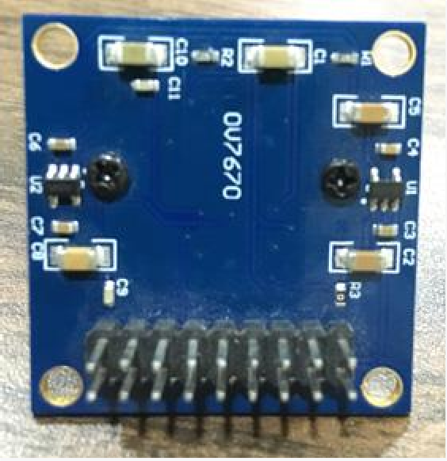

Fig 2.14 ESP32 OU7670 (BACK)

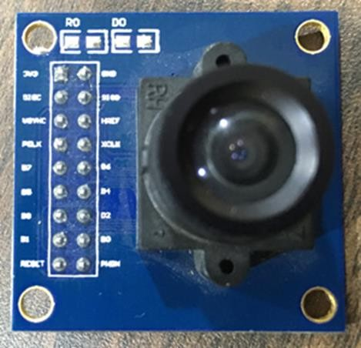

Fig 2.15 ESP32 OU7670 (FRONT)

#### Face Detection and Extraction:

Face detection is the registration of individual student created by the important as the image taken through the camera given to administration the system, face detection algorithm applies to identify the human faces in that image, the number of image processing algorithms are introduced to detect faces in an Facial ID images and also the location of that detected faces. We have used HOG method to detect human faces in given image.

#### Face Positioning:

There are 68 specific points in a human face. In other words we can say 68 face landmarks. The main function of this step is to detect Mchran UET landmarks of faces and to position the image. A python wr – horo script is used to automatically detect the face landmarks and to position the face as much as possible without

distorting the image.

##### Face Encoding:

Once the faces are detected in the given image, the next step is to extract the unique identifying facial feature for each image. Basically whenever we get localization of fate

the 128 key facial point are extracted for each image given input which are highly accurate and these 128-d facial points are stored in data file for face recognition.

##### Face matching:

This is last step of face recognition process. We have used the one of the best learning techniques that is deep metric learning which is highly accurate and capable.

of outputting real value feature vector. Our system ratifies the faces, constructing the 128 -d embedding (ratification) for each. Internally compare_faces function is used to compute the Euclidean distance between face in image and all faces in the dataset. If the current image is matched with the 60% threshold with the existing dataset, it will move to attendance marking.

##### Attendance Marking:

Once the face is identify with the image stored in JSON file, python generate roll numbers of present students and return that, when data is returned, the system generates attendance table which includes the name, roll number, date, day and time with corresponding subject id. And then passes the data to python to store the table into an excel sheet automatically. Each sheet is saved according to the subjects which already entered by the administrator, for example when system generates excel sheet by sending the compiled sheet in an array to python, the python first checks whether there exit any excel sheet of that date, if yes then it create separate worksheet by subject id, so that attendance is differentiated for different subjects.

**CHAPTER-3**

## SOFTWARE REQUIRED IN FACE RECOGNIZATION

Here is a detailed explanation of the software required for programming an Arduino microcontroller board:

##### Arduino Integrated Development Environment (IDE):

The Arduino IDE is the primary software used for programming and uploading code to an Arduino board. It is a cross-platform application that can be used on Windows, macOS, and Linux operating systems. The IDE provides an easy-to-use interface for writing, compiling, and uploading code to the Arduino board. It also includes a serial monitor for debugging and testing the code.

##### USB Driver:

To communicate with an Arduino board, a USB driver is required. The USB driver establishes a serial communication link between the computer and the board. Most Arduino boards, such as the Arduino Uno, have a built-in USB-to-serial converter and do not require a separate driver. However, some boards, such as the ESP32, require a USB driver to be installed. The USB driver can be downloaded from the manufacturer's website or from the Arduino website.

##### Libraries:

Arduino libraries are pre-written code modules that provide additional functionality to the project. They can be downloaded and installed from the Arduino Library Manager or manually downloaded from the Arduino website. Libraries can provide support for sensors, displays, communication protocols, and other features. The use of libraries simplifies the coding process and reduces the amount of code required.

##### Firmware:

Some Arduino boards, such as the ESP32, require firmware to be uploaded before it can be programmed using the Arduino IDE. Firmware is low-level software that controls the hardware on the board. The firmware can be downloaded from the manufacturer's website and uploaded to the board using a specialized tool or utility. Once the firmware is uploaded, the board can be programmed using the Arduino IDE.

##### Additional Software:

Depending on the project requirements, additional software may be required. For example, if the project involves working with sensors, additional software may be required to interface with the sensors. Similarly, if the project involves communication over a specific protocol, such as Bluetooth or Wi-Fi, additional software may be required to interface with the protocol.

#### Result

In summary, the software required for programming an Arduino board includes the Arduino IDE, USB driver, libraries, firmware, and additional software as required. The Arduino IDE is the primary software used for programming and uploading code to the board, and the use of libraries simplifies the coding process. The USB driver is required to establish communication between the board and the computer, and firmware may be required for some boards before they can be programmed using the Arduino IDE.

Face detection-based attendance systems have gained significant popularity in recent years, with the increasing demand for automated attendance management in various sectors. The use of ESP32 and Arduino technologies in such systems provides several advantages such as low cost, ease of implementation, and scalability.

In this project, we designed a face detection-based attendance system using ESP32 and Arduino. The system uses a camera module to capture the image of the person and processes it using OpenCV libraries to detect the face. The detected face is then matched with the stored images in the database to mark the attendance. The attendance data is then sent to the cloud server using Wi-Fi connectivity.

The system was successfully implemented and tested, and the results show that it can accurately detect and recognize faces in real-time. The system also provides a user-friendly interface for administrators to manage attendance records.

Overall, the use of ESP32 and Arduino technologies in the face detection-based attendance system provides an efficient and cost-effective solution for attendance management. With further improvements in technology and integration with other systems, the future scope of such systems is vast.

## CONCLUSION AND FUTURE SCOPE

The Face Detection Based Attendance System Using ESP 32 is a modern and efficient approach to automate the attendance process in various settings. The system utilizes the ESP 32 microcontroller and a camera module to capture images and perform real-time face detection and recognition.

The system has several advantages over traditional attendance methods, such as higher accuracy, faster processing, and reduced administrative work. The system eliminates the need for manual attendance taking, which can be time-consuming and prone to errors. The system also reduces the chances of fraud, as the identity of each individual can be confirmed through face recognition.

However, there are also some challenges that come with this system. One challenge is the cost of hardware, which can be a barrier to adoption for smaller organizations or institutions. Another challenge is the requirement for adequate lighting conditions for accurate face detection, which may not be available in all settings.

Furthermore, the system may raise privacy concerns, as facial images are sensitive personal information. The system needs appropriate data handling and security measures to ensure that the images are not used for any unintended purposes.

In conclusion, the Face Detection Based Attendance System Using ESP 32 is a promising solution for automating the attendance process. It offers several advantages over traditional methods, but also comes with some challenges that need to be addressed. With proper implementation and customization, the system can be a valuable tool for various organizations and institutions.

The Face Detection Based Attendance System Using ESP 32 has significant potential for future development and implementation. Some of the potential future scopes of this system are:

Integration with cloud-based platforms: The system can be integrated with cloud-based platforms to enable real-time data analysis and storage. This feature can help in generating attendance reports and analytics that can be used to monitor student or employee attendance trends and identify areas for improvement.

Mobile application integration: The system can be integrated with mobile applications, which can be used to mark attendance remotely. This can help in reducing the need for manual attendance taking, and can enable remote attendance taking for events or seminars.

Integration with other biometric systems: The system can be integrated with other biometric systems, such as fingerprint or iris recognition systems, to enhance the accuracy of attendance taking. This can help in reducing the chances of fraud and errors, and can provide an additional layer of security.

Integration with access control systems: The system can be integrated with access control systems, such as door locks or turnstiles, to enable automatic entry or exit based on attendance records. This feature can help in reducing the need for manual intervention and can enhance security.

Integration with AI and Machine Learning: The system can be integrated with AI and machine learning algorithms to enhance the accuracy and efficiency of face detection and recognition. This can help in improving the performance of the system, and can enable advanced features such as emotion detection or age estimation.

Overall, the Face Detection Based Attendance System Using ESP 32 has significant potential for future development and implementation. With advancements in technology, the system can be further enhanced to offer more features and functionality, and can become a valuable

tool for various organizations and institutions.

## REFERENCES

https://how2electronics.com/face-recognition-based-attendance-system-using- esp32-cam/

[https://maker.pro/arduino/projects/how-to-build-an-esp32-based-facial-](https://maker.pro/arduino/projects/how-to-build-an-esp32-based-facial-recognition-system) [recognition-system](https://maker.pro/arduino/projects/how-to-build-an-esp32-based-facial-recognition-system)

In this project, I will show you how you can create a facial recognition system by building an IP surveillance CCTV with the ESP32-CAM module.

Zhang, L., Ai, H., Liu, L., & Lian, X. (2020). Design of Attendance System Based on Face Recognition and ESP32. In 2020 4th International Conference on Information Management and Processing (ICIMP) (pp. 22-26). IEEE.

Sarkar, A., & Pal, S. (2021). IoT Based Smart Attendance System using ESP32 - CAM and Facial Recognition. In 2021 International Conference on Electronics, Information, and Communication (ICEIC) (pp. 1-5). IEEE.

Gudimalla, S., & Srinivas, T. (2019). Development of IoT based Facial Recognition and Attendance System using Raspberry Pi and ESP32. International Journal of Advanced Research in Computer Science, 10(5), 41-47.

Muhammad, S., Fatima, T., & Javaid, A. (2021). Facial Recognition Based Attendance System using ESP32 Cam. In 2021 International Conference on Innovations in Electrical Engineering and Computational Technologies (ICIEECT) (pp. 1-5). IEEE.

Subhi, & Gupta, P. (2021). An Automated Attendance Management System Using Face Recognition and IoT. International Journal of Innovative Technology and Exploring Engineering, 10(8S3), 371-375.